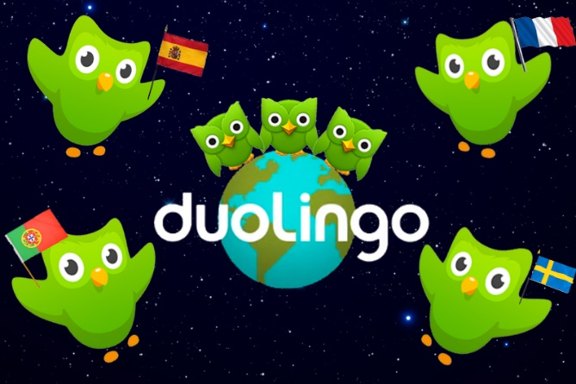
Duolingo is the world's largest online language learning platform and the most downloaded education app in the world for both Android and iOS devices. It was recognized as Apple's iPhone App of the Year in 2013 as well as Google Play's Best of the Best in 2013 and 2014. Duolingo has over 200 million users, is completely science- and data-based, and has gamified elements that make learning more fun. I chose to pursue Spanish due to the fact that there is still a lot that I don’t know about in Spanish. For ex. Accents and how sentences are formed or said because even though I know Spanish because that is my first language but every single Spanish speaking country has a different way of speaking Spanish. They each have its twists and turns that they throw into the Spanish language.

